PCSD Virtual Hotspots

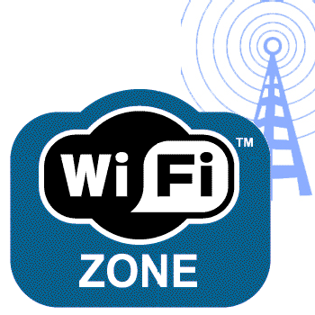

The following churches are supporting our efforts to provide internet access to our community by serving as host locations for our virtual hotspot buses:

Mt. Olivet Missionary Baptist Church
3228 Highway 101 North
Rockmart, Georgia 30153

Shiloh Baptist Church
209 West Cooper Avenue
Dallas Georgia 30132

Dallas First United Methodist Church
141 East Memorial Church
Dallas, Georgia 30132

Oasis
210 Paulding Lane
Dallas Georgia 30132

West Ridge Church
3522 Hiram Acworth Hwy
Dallas, Georgia 30157

