How to Sign-Off on MyAP as a Parent/Guardian
The Paulding County School District utilizes a tool called My Academic Planner (MyAP) to register students for classes. Once the registration process at the school is complete, parents will need to log into their parent portal account through Infinite Campus and sign-off on their student’s plan. Every student must have their plan approved by a parent/guardian. Please follow the directions below, and should any questions arise, please contact your middle school counselor.

Step 1: Click on the following link and review all Advisement information for 8th to 9th grade students & parents:
- https://www.paulding.k12.ga.us/cms/lib/GA01903603/Centricity/Domain/5820/IGP%20Reminders%20.pdf

Step 2: Go to the Parent Portal Login:
- Link: https://campus.paulding.k12.ga.us/campus/portal/paulding.jsp
  - Login using your user name and password
  - If you do not have a user name, contact your school’s front office to get one

Step 3: Select your student from the top of the screen:

Step 4: Click on the “Academic Plan” tab on the left side of the screen
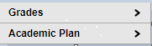

Step 5: Click “Next” on the screen. Do not change any of the drop down boxes.
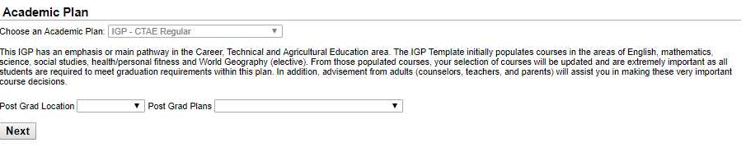

Step 6: You will now be able to see your student’s classes. Please look these over, and contact
your high school counselor if you have questions or concerns.
⇒ Click on the box that says “I _________ approve this academic plan”
⇒ Then click the “Save” button. The process is complete.
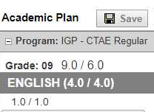

Note: When you click save, you may receive warning messages and will review and update your students schedule of courses if necessary. Some student’s may receive a warning message regarding needing a Fine Arts credit. If your student has earned or plans to earn 3 credits in a CTAE or World Language, they do not need a Fine Arts credit.

